

Year 10 Science

**Biology 1 Test: DNA and Inheritance**

**SECTION 1: MULTIPLE CHOICE** (1 mark each)

Circle your answer on the multiple-choice answer sheet.

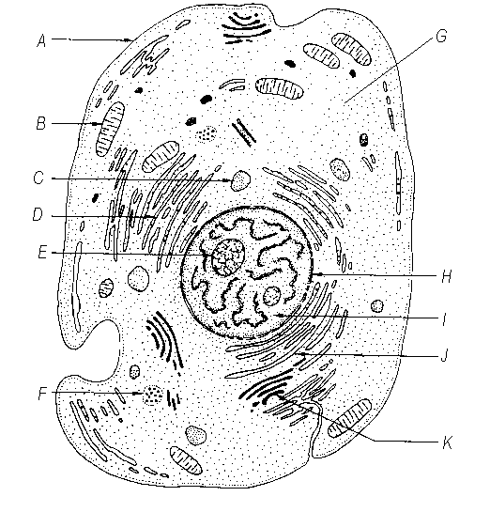

The part of the cell that is labelled I is the

* 1. nucleolus
  2. nucleus
  3. nuclear membrane
  4. cytoplasm

1. Which of the following structures are made out of DNA?
   1. chromosomes
   2. chloroplasts
   3. cell membranes
   4. mitochondria
2. How many different bases make up the “genetic alphabet” of DNA?

a) 2

b) 3

c) 4

d) 5

1. What shape is a DNA molecule?

a) X shaped

b) Double helix, like a twisted ladder

c) Star shaped

d) Arch shaped, like a rainbow

1. Which of the following statements is incorrect about chromosomes?
   1. Chromosomes are made of DNA.
   2. Chromosomes are found in the nucleus.
   3. Chromosomes contain genes for inheritance.
   4. Chromosomes are always visible under a microscope in stained cells.
2. Which of the following is correct about asexual reproduction?
   1. It results in greater diversity than sexual reproduction.
   2. The offspring are all identical to their parents.
   3. It involves two parents.
   4. It only occurs in bacteria and single celled organisms.

*The next three questions refer to the diagrams below, which are microscopic photographs of a cell at various stages of mitosis.*

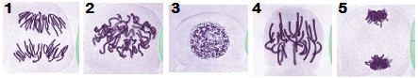

1. The correct sequence for these stages is
2. 1,2,3,4,5
3. 3,2,5,4,1
4. 3,2,4,1,5
5. 2,5,4,1,3
6. Diagram “1” shows which phase of mitosis?
   1. Interphase
   2. Prophase
   3. Metaphase
   4. Anaphase
7. During which phase does replication (copying) of DNA occur?
   1. Interphase
   2. Prophase
   3. Metaphase
   4. Anaphase
8. The process that produces gametes (eggs, sperm and pollen) is called
   1. mitosis.
   2. meiosis.
   3. cloning.
   4. fertilisation.
9. A sudden change in genetic make-up that results in a new characteristic which is inheritable is called a
   1. multiple allele.
   2. lethal factor.
   3. mutation.
   4. chromosome.
10. Two black dogs may have black or brown pups, but two brown dogs will only have brown pups. This is because
    1. black colouring is dominant to brown colouring.
    2. black colouring is recessive to brown colouring.
    3. black and brown colouring are co-dominant.
    4. black colouring is more common in dogs.

13. 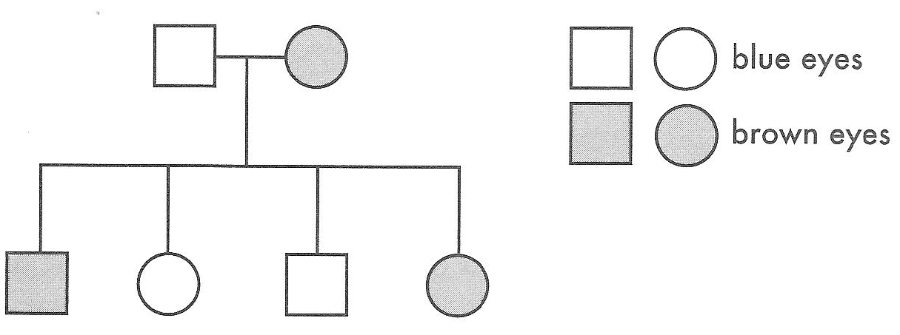

If brown is dominant to blue, which of the following is possible?

1. the mother is homozygous and the father is heterozygous for eye colour
2. the father is homozygous and the mother is heterozygous
3. the father and mother are both homozygous
4. the father and mother are both heterozygous
5. In humans, sex is determined by one pair of chromosomes out of the 23 pairs. Females are
   1. XX
   2. XY
   3. YX
   4. YY
6. Sex-linked recessive characteristics like red-green colour blindness and haemophilia are more common in
   1. males
   2. females
   3. homozygous individuals
   4. individuals with extra chromosomes
7. The genetic code for an individual for a particular trait is called
   1. allele
   2. genotype
   3. phenotype
   4. a punnet square
8. Mutations caused by insertion or deletion of one or more bases cause the information following it to be jumbled so that it cannot be read to make a protein. These types of mutations are called
   1. silent
   2. misssense
   3. nonsense
   4. frameshift
9. In budgerigars, green feather colour (G) is dominant to blue feather colour (g). Two heterozygous green budgerigars are mated, what are the most probable phenotypes of the offspring?
   1. All the offspring will be green
   2. All the offspring will be blue
   3. The offspring would be 50% green and 50% blue
   4. The offspring will be 75% green and 25% blue
10. Cells present in new embryos for a few days after fertilisation, which are capable of becoming any type of cell in the body are called
    1. plasmids.
    2. Modifiers.
    3. stem cells.
    4. Carcinogens.
11. Which of the base sequences below would pair with the following DNA strand?

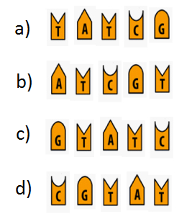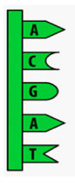

**SECTION 2: WRITTEN**

**Write your answers in the spaces provided. Show all working.**

1. In mice, black fur is dominant to brown fur. Predict the possible genotypes and phenotypes of the offspring if a homozygous black male was crossed with a homozygous brown female. (5)

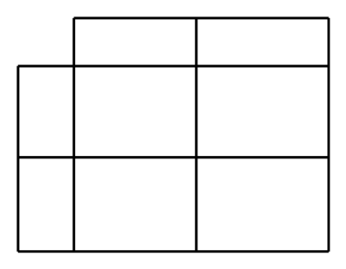

1. In Drosophila fruit flies the gene for red eyes is dominant, while the gene for white eyes is recessive and sex linked (Xr). What possible phenotypes and genotypes would result from a cross between a red eyed male (XRY) and a heterozygous red eyed female (XRXr)? (5)

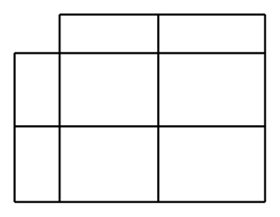

1. Look at the pedigree chart and answer the questions below.

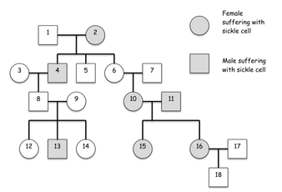

|  |  |  |
| --- | --- | --- |
| 1. What is the relationship between 2 and 4? |  | (1) |
| 1. How many children did 8 and 9 have? |  | (1) |
| 1. Is this condition dominant or recessive? |  | (1) |
| 1. What is the genotype of 2? |  | (1) |
| 1. What is the genotype of 6? |  | (1) |
| 1. What is the probability of 8 and 9 having another child with sickle cell? |  | (3) |

1. State one argument for and one argument against the use of genetically modified crops

(2)

_________________________________________________________________________________________________________________________________________________________________________________________________________________________________________________________________________________________________________________________________________________________

END OF TEST (OUT OF 40 MARKS)